Unexpected connections
will bring classical music to South Bohemia.
The 34th Festival Krumlov starts on Friday.

press release, July 9, 2025

Emotions, elegance, and the courage to connect borders. In just a few days, from July 11 to August 2, 2025, the picturesque corners of Český Krumlov and other places in the South Bohemian Region will be resounding with the 34th International Music Festival Český Krumlov. It will offer 45 concerts in the style of the main theme Unexpected Connections. Renowned names from all over the world will be presented, Czech and international premieres will take place, and surprising musical and other artistic connections will emerge in new locations where classics have not been played before. All this with respect for Český Krumlov and the entire South Bohemian Region and with enthusiasm for the future.

The Krumlov Festival is not just an international show; it is an event deeply rooted in the landscape and history of South Bohemia. Classical music here connects genres, eras, generations, styles, and communities. World-class music brings feelings and experiences to authentic places, big stars and young talents are given the opportunity, and classical tones are discovered by people regardless of age or social status.

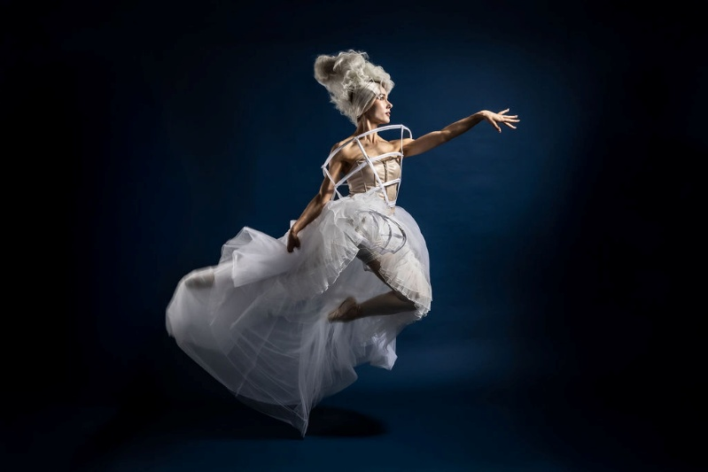
"This year we invite the audience to unexpected connections with art in all its forms. The main stars include violinist Maxim Vengerov, guitarist Pablo Sáinz-Villegas, vocal legends Take 6, mezzo-soprano Ester Pavlů, guitarist Štěpán Rak, tenor Joseph Calleja, ballet choreographed by Jiří Bubeníček, and others. The unique opening concert Unexpected Baroque on the lake in the castle park also symbolizes the essence of the festival - to find new ways to convey art in the authentic and inspiring backdrops of Český Krumlov and the South Bohemian Region," says Gabriela Rachidi, director of the Krumlov Festival.

🎬 Start on the Water:
Unexpected Baroque
The opening concert on Friday, July 11th will transform the pond, the trees, and the twilight in the castle park into a magical scene. The soprano Simona Houda-Šaturová, trumpeter Pacho Flores, dancer Ida Victoria Nowakowska, the Barocco sempre giovane orchestra and conductor Vojtěch Spurný will perform. All under the artistic direction of RUN OPERUN.

“Unexpected Baroque will be a living baroque dream. Music, movement, light and landscape will merge into one,” says director and screenwriter RUN OPERUN Vilma Bořkovec, adding: “The space will transform into one living whole and unexpected connections in an unconventional baroque guise will appear everywhere the viewer looks.“

“With imagination, we can be offline and more alive. Unexpected Baroque will give a platform to dream and discover – through music, space, and movement. Dance and music are a universal language, and South Bohemia is the ideal backdrop – peaceful and at the same time strong in the story,” adds Polish American star Ida Victoria Nowakowska.

🌍 South Bohemia and Český Krumlov as part of the festival’s DNA
The Festival Krumlov has its roots firmly planted in the South Bohemia region. Concerts take place not only in the iconic UNESCO city of Český Krumlov, but also in Kaplice or Boletice, and this year also in České Budějovice. The International Classical Festival also gives opportunity to artists with ties to South Bohemia – many performers are directly connected to the region. From the South Bohemian Philharmonic, which will play with violinist Jan Mráček and the winner of the Virtuosos 2025 competition, to talents from the České Budějovice Conservatory, who will perform in the Monastery Garden during Spanish Saturday. The Kaplice Music Day will take place for the first time, in addition to professional artists, students from the Kaplice Primary School will perform. The concerts will be performed at 15 South Bohemian locations, three of which – the Porta Portal 1560 in Český Krumlov, the Church of St. Peter and Paul and the city park in Kaplice – for the first time.

“The South Bohemian Region has long supported festivals that develop the cultural identity of the region and inspire at the same time. The Festival Krumlov is a great example of a dialogue between tradition, generations and the new era,” says Lucie Kozlová, Deputy Governor of the South Bohemian Region for Culture, and adds: “The revival of culture, tourism, motivation for young artists, all of this is related to culture, the benefits are incalculable and long-term, which is why we are very happy to be part of the festival events.”

“The Festival Krumlov is not just a world-class event, nor just a privilege for tourists. It is also beneficial for the residents of the city and the region. Thanks to it, music reaches parks, churches and schools,” says Alexandr Nogrády, Mayor of Český Krumlov, and adds: “The festival is thus one of the pillars of the cultural identity of Český Krumlov, we very much welcome the fact that it is expanding outside the center, organizing events outside the main tourist season, or bringing classical music to Kaplice.”


The 34th year will also pay tribute to the guitar master Štěpán Rak, who is celebrating his 80th birthday and founded the guitar department at the Faculty of Education in České Budějovice. Mezzo-soprano Ester Pavlů, whose father hails from Jindřichův Hradec and who went to Český Krumlov for summer music courses with Professor Vladimír Chmel, will also perform. Also performing will be clarinettist Marek Švejkar, who taught at the Music Gymnasium in České Budějovice. As for the composers whose work will be heard at the festival, for example, Antonín Dvořák drew inspiration from the Třeboň region, Bedřich Smetana studied in Jindřichův Hradec, etc.

🗺️ Festival Zone and KrumlOFF
And the Festival Zone, i.e. the accompanying program with free admission in the Monastery Garden? It will also be full of local connections and artists. For example, there will be creative workshops with Aleš's South Bohemian Gallery, fairy-tale Thursdays for children with South Bohemian theaters, Krumlovský Montmartre, where it will be possible to create with local painter Jiří Zábranský, a concert will be given by the South Bohemian folk music group Nahoře, the Krumlovský mixed choir Perchty will perform, etc. There will also be summer cinemas with Kooperativa with films such as Lemonade Joe or The Horse Opera or Long Live the Ghosts.

The festival is not limited to the city of Český Krumlov and July and August. Concerts and other events take place throughout the year and throughout the region. Events that are in cooperation with South Bohemian, national and foreign organizations, combined in a coherent dramaturgy, form the KrumlOFF concert series. During its 34th year, the festival brought Classical Music for Schools to the Plešivec Elementary School in Krumlov, during Advent on the Krumlov Square, the Christmas concert Up, and in May, as a commemoration of the 80th anniversary of the end of World War II, the musical-experience performance The Story of Kende's Villa in České Budějovice.

❤️ Help that resonates
The festival strives to help people develop the best possible relationship with classical music and believes in its positive impact. At the same time, it creates a platform that aims to be beneficial. Therefore, the proceeds from the sale of concert programs have long-term supported the Jaroslav Ježek Elementary School – a school for blind children and from the sale of the Elementary School festival brochure in Český Krumlov. Benefit concerts are also an integral part of the program. In addition, it provides a temporary home for the KUŘE – Help the Children project, this year in the form of Grains for Chicken with a voluntary admission fee, and provides space for events of the Czech Red Cross or creative workshops for disadvantaged children and their families, including from the Autism as a Gift organization.

“The Festival Krumlov is an example of a cultural event that thinks of everyone,” says Hana Machačová, Chairwoman of the Board of Directors of the Kooperativa Foundation, adding: “It is essential for Kooperativa that it addresses the general public regardless of age or socio-economic factors – from children, through teenagers, adults to seniors – and creates a creative, welcoming, entertaining and educational environment in which people feel welcome, inspired and safe. It is precisely this connection of values ​​and care that makes sense to support.”

The general partner of the 34th Festival Krumlov is the Kooperativa insurance company, the main companies are ČEPS and Audi ČR, the official ones are Madeta, Reticulum and the Český Krumlov Development Fund. The festival is held with the support of the Ministry of Culture, the South Bohemian Region, the city of Český Krumlov and the Czech Tourism Board – CzechTourism. We would like to thank them and all other partners and patrons, including media partners. And all the artists who will perform at the event. More at www.festivalkrumlov.cz.

Contact: Štěpánka Filipová, PR manager & spokesperson, filipova@festivalkrumlov.cz, +420 724 302 802

📊 Key facts about the 34th Festival Krumlov
Date of event | 11. 7. – 2. 8. 2025
Topic | Unexpected Connections
Concerts | 45 of which 25 in the main concert series
Concert venues | 15 of which 3 are new – the Church of St. Peter and Paul in Kaplice, the Kaplice city park, the Portal of Port 1560 in Český Krumlov
Artists | more than 400
Concert series | 7 - main, chamber, organ, new connections, young talents, Concerts in the gardens, Site-specific
Premieres | world premiere of the composition Sulle rovine del tempo (On ​​the ruins of time), Czech premiere of the baroque opera: Handel – Alessandro Severo, world premiere of a composition by Jiří Trtík commissioned by PBtet and the Festival Krumlov
Opening ceremony | Unexpected Baroque
Closing Ceremony | Passionate Carmen: opera, ballet
Highlights | Violin virtuoso: Maxim Vengerov, Congratulatory concert: Štěpán Rak 80, Frivolous classics, Spanish night: Pablo Sáinz-Villegas, Baroque opera: Handel – Alessandro Severo, Vocal geniuses: Take 6, Jan Mráček and Virtuosos 2025
Festival Zone | fairy tale Thursdays, relaxing Fridays, Saturdays with the family (12/7 Chicken Day, 19/7 Spanish Saturday), classic Sundays
Web | www.festivalkrumlov.cz



